What is the project about

Intelligent browser is an AI driven browser, joh user input tasks krta hai efficiently, and by using automation, so it gives you the handless experience.

Kya karta hai

Functions

Languages

Functions and libraries used

What is javascript.. basic codes dekh lena

Objects- written inside curly backets, const obj_name= { property:value pair}

Json-javascript object notation

Python ke bhi

ML

Nlp

Through natural language toolkit- lib in python

And nltk mein there are functions like word_tokenize, PorterStemmer

Through natural language toolkit- lib in python

And nltk mein there are functions like word_tokenize, PorterStemmer

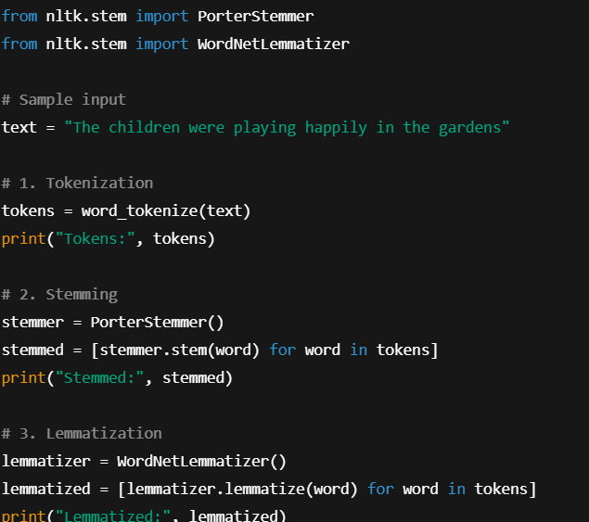

Punkt , tokenisation, stemming

Vectorisation – converts word to numbers

Bag of words- how many times each word appears

TF-IDF- term freq- inverse doc frequency- how imp the occurring word is compared to others

CountVectorise()- used to convert text into numeral vectors

punkt is a tokenizer model provided by the NLTK

vectoriation is carried out through scikit-learn- ML library in python

after finding intents API is used to break down the sentence (parse intents) and analyse

Html, css, php

Automation

Headless- browser runs without opening a visible window

What is puppeteer and playwright

These are node.js libraries, that lets us navigate thru web pages

Encryption- necessary for security of all the passwords, information and api key

AES-256- advanced encryption standard – protected data with a super strong key which only authorised parties can read

OaAuth 2.0- lets user give access of their data without passwords

PostgreSQL- relational database, stores data, like login credentials, history

Why me

Im enthusiastic about ai.ml, and im currently working on a project kinda related to it toh mujhe aur seekhna hai, I’ll give as much as time as possible, even though mujhe jyda coding pehle se nhi aati, im a quick learner and will try my level best.